Elisa Medhus- Tarot Card Reading
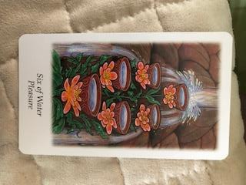
The Six of Water Currently your life force is relaxed- flowing calmly and sweetly. This a great time to tackle new projects with self-confidence and ease. Because you’re so relaxed and hanging loose right now, it’s a perfect time to get people up-to-date on emotional matters.
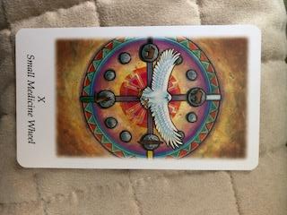
The Small Medicine Wheel card is the heart of this reading and message. You are in the process of a new beginning, an old cycle has ended and a fresh one has begun. The Eagle sits in the east and represents furthering spiritual growth and consistently following your path. The Coyote in the south represents innocence and ability to trust; call on it to stay in touch with your own feelings and find balance. The Bear sitting in the west knows the answers to your deepest questions and reminds you of your own truth; even though it may flux. Finally, the Buffalo is positioned in the north represents all-encompassing wisdom, remembering how to give to others and the importance of gratitude. You will need the values, abilities, skills (medicine) inherent in these four animals to successfully embark on this new and exciting personal journey that will ultimately be fulfilling.
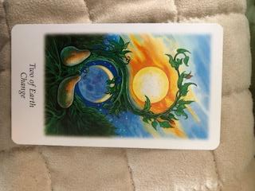
The Two of Earth doubles down on the message of a new beginning and change. You must let go of past practical situations and hold a degree of non-attachment for this new journey. Like all adventures- there will be good times and bad times. Being aware that there are successes and failures in life, and not attaching too strongly to either- but learning from both will ultimately serve you in this new cycle.
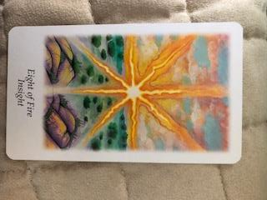
The Eight of Fire allows for an easy grasp of any situation. You intuitively aware of the heart of the matter and act accordingly to the benefit of all. Who discovers the solution is not as important as the outcome benefiting everyone involved. There is a sharpened ability to cut through the fog and speak from the heart- ignoring the mambo jambo. You are more frank, honest, and willing to clear up personal matters during this new period. Since you have nothing to hide or protect you can share your insights openly with no reluctance.
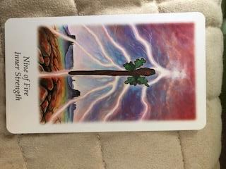
The Nine of Fire signifies you are riding a high surge of energy. You are open to new ways of communicating due to having a plentiful amount of energy. This concentrated energy and strength will be invested in a new creative endeavor that will ultimately be more fulfilling than past areas.
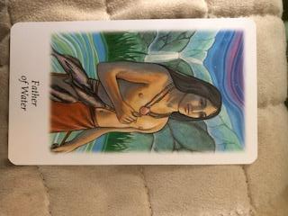
The Father of Water. You will embark on a new creative area and within this area you will find the change and fulfillment you desperately needed. Part of this new creative activity will include you using your non-judgmental perceptiveness and desire to share intuitive insights- to comfort and assist others. A heightened sensitivity allows you to be more in touch with the supernatural realms, which provide pinpoint accurate insights.

Important Themes: Change, New creative pursuits, insightfulness to best understand others, high energy to tackle new creative pursuits and obstacles with confidence, relaxed yet high energy causes you to face changes head on without much stress

Daniel Klein is a 26 year old, clairvoyant healer- whose been in touch with his psychic abilities since age 6, and conducting readings for 10 years. He offers general psychic readings, and tarot card readings. His services are a sort of holistic therapy. He’s also a writer of fiction, poems, short stories and has been performing stand-up comedy since 2015- at the likes of Dangerfield’s and Broadway Comedy Club in Manhattan,NY. He can be reached at danielklein@dapsychics.com and his website is www.dapsychics.com

